

|  |  |  |  |  |  |  |  |  |
| --- | --- | --- | --- | --- | --- | --- | --- | --- |
|  | | | | | | | | |
|  | |  | | | | |  | |
|  |  | | | | | | |  |
|  | | | |  |  | | | |
|  | | | | **User Guide** |  | | | |
|  | | | | **Team Members** Kwatt Ivy  Chua Jack Yune  Nilothpal Bhattacharya  Borromeo, Angelie Quiapo |  | | | |
|  | | |  | | |  | | |

|  |  |  |  |  |  |  |  |  |
| --- | --- | --- | --- | --- | --- | --- | --- | --- |
|  |  | | |  |  | | |  |
|  | Getting Started | | | | | | |  |
|  |  | | |  |  | | |  |
|  |  | | System Requirements  myUpskill Chatbot Career Recommender system has been tested on the following Web Browsers:   * Microsoft Edge * Google Chrome * Safari Version | | |  | |  |
|  |  |  |  | | |  |  |  |
|  | | | | |
|  |  |  |  |
|  |  |

|  |  |  |  |  |  |
| --- | --- | --- | --- | --- | --- |
|  | |  |  | |  |
|  | | Quick Start | | | | |  |
|  | |  |  |  | | |  |
|  | | * Create a Login account by opening the below link into the browser of your choice   **URL:** <http://localhost:8080/> | | | | |  |
|  | | * Fill in the required details and click “Sign Up” | | | | |  |
|  |
|  |

* To Login provide your login details then click the “Login” button.

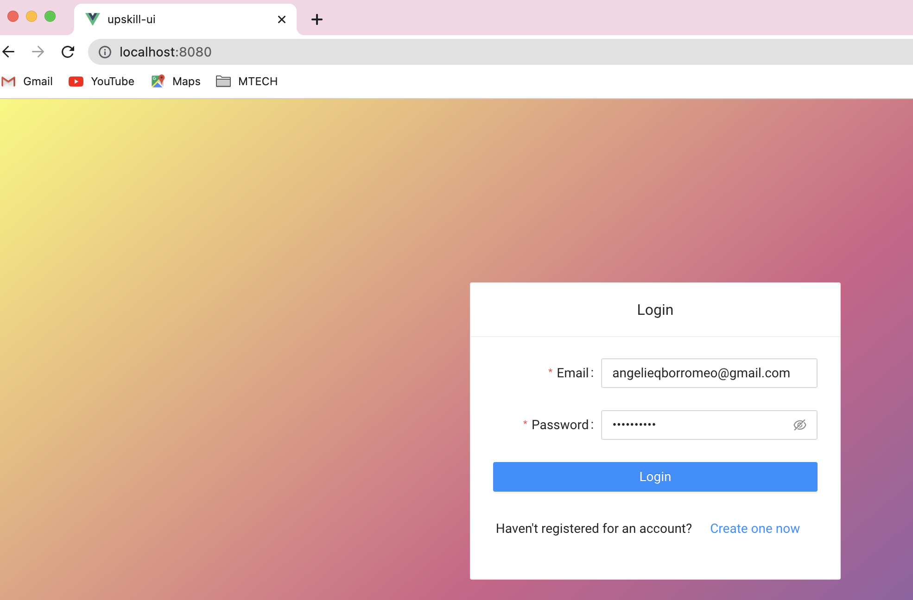

* Start chatting with JINA (myUpskill Chabot)
* You can start by greeting “Hi” and JINA our chabot assistant will start prompting question.

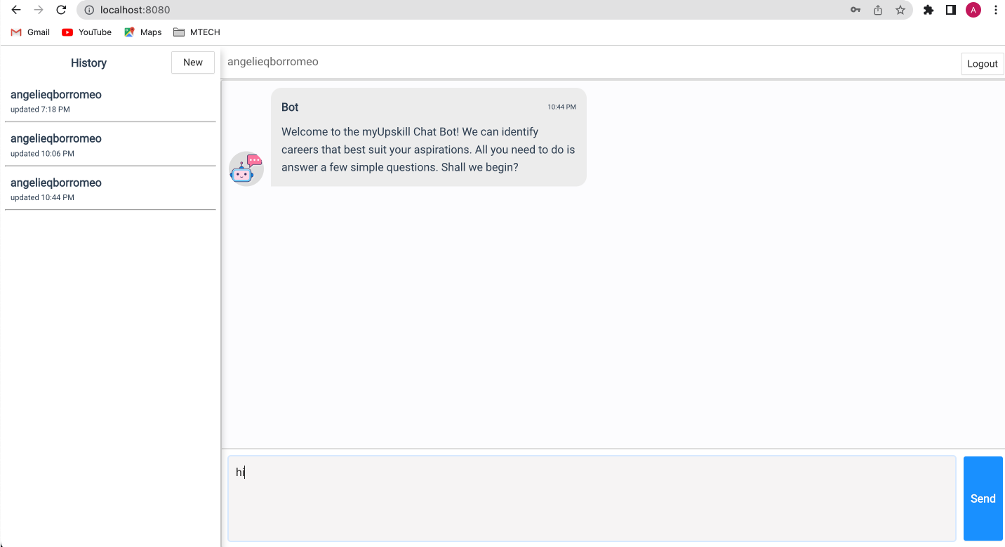

* Below the bot as to “describe the in details what you would like to do for a living”

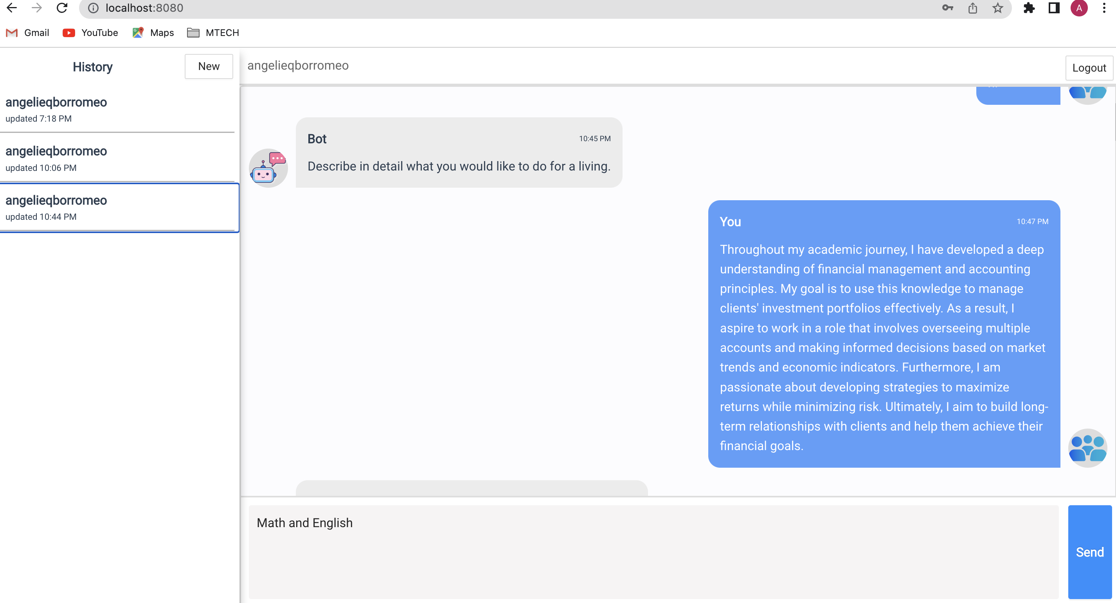

* The bot will ask couple of other question

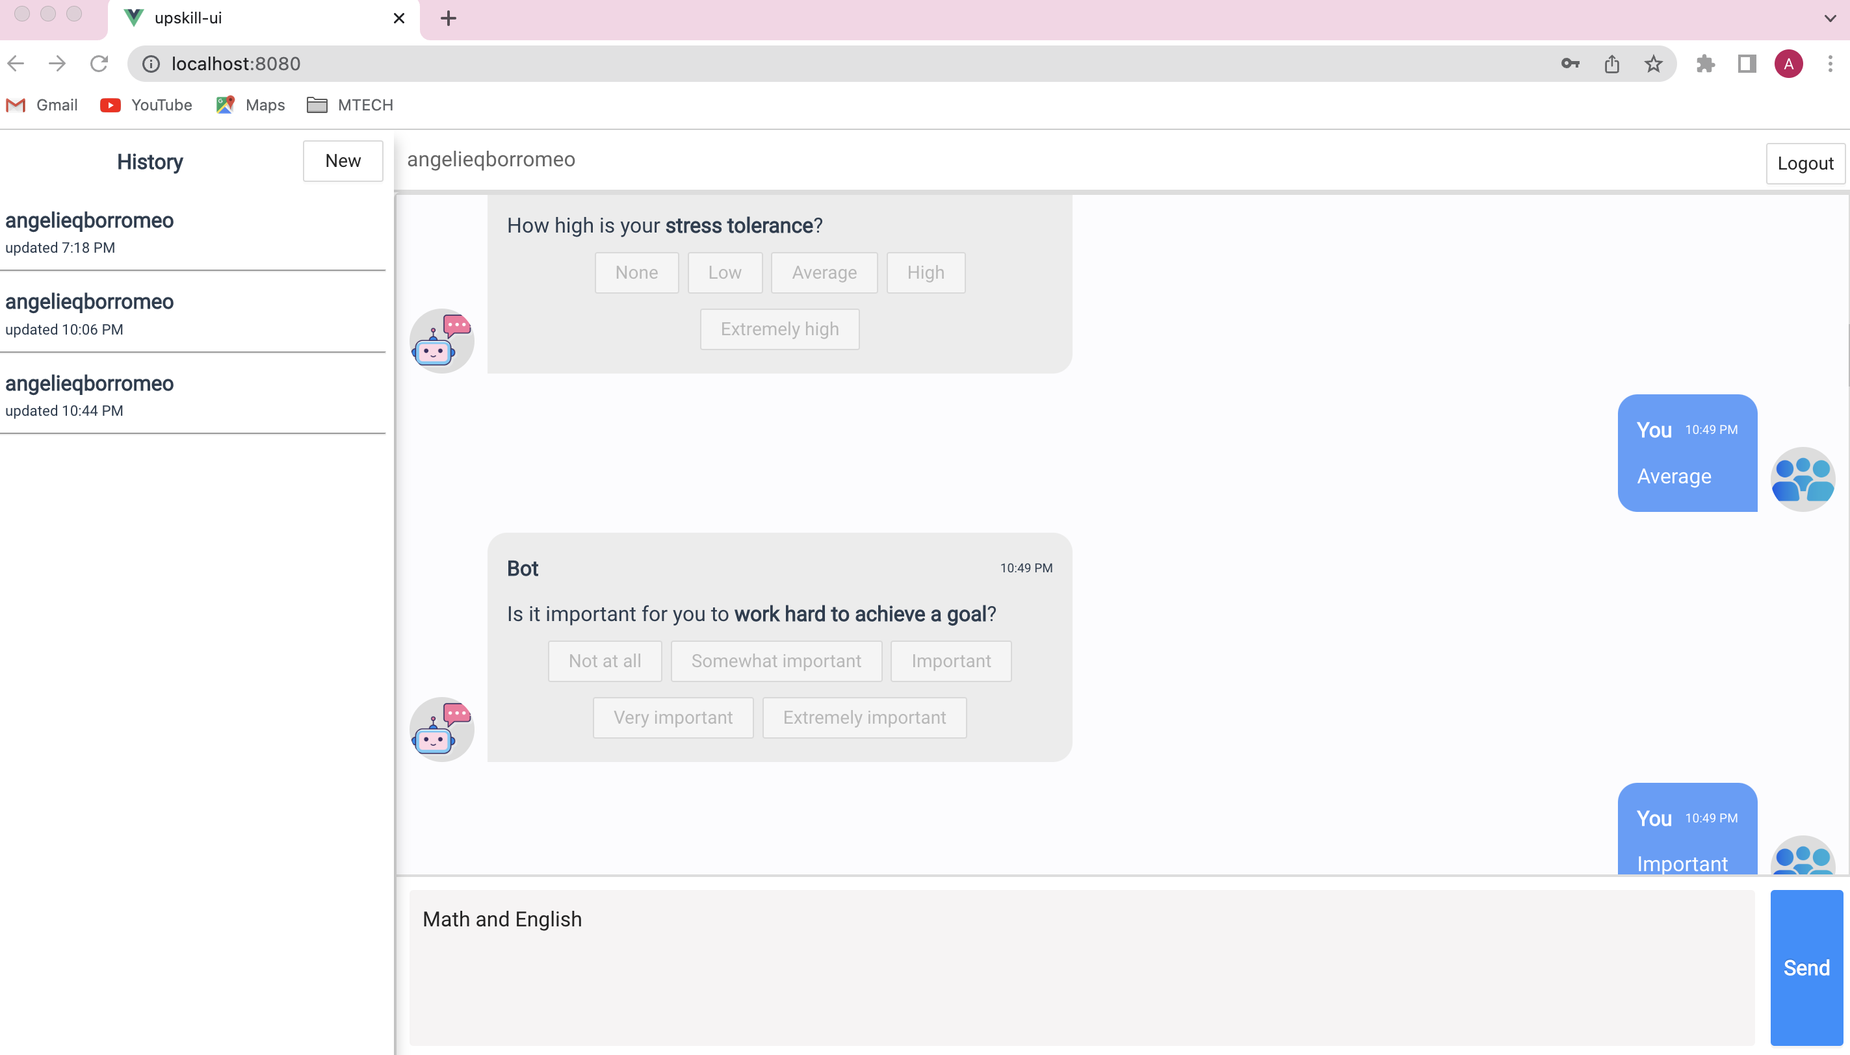

* You can click the green line to get your results

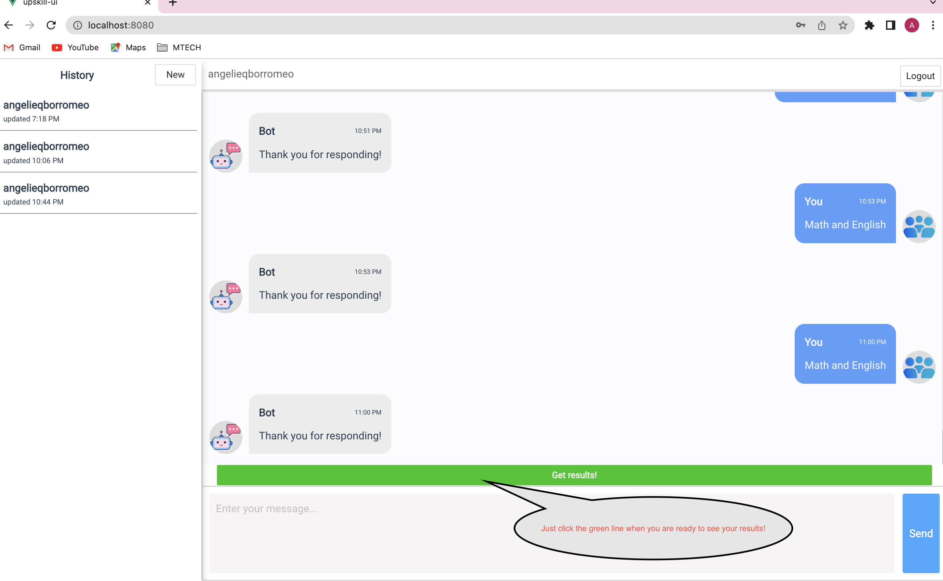

* List of available careers can be seen and check by clicking “more” button.

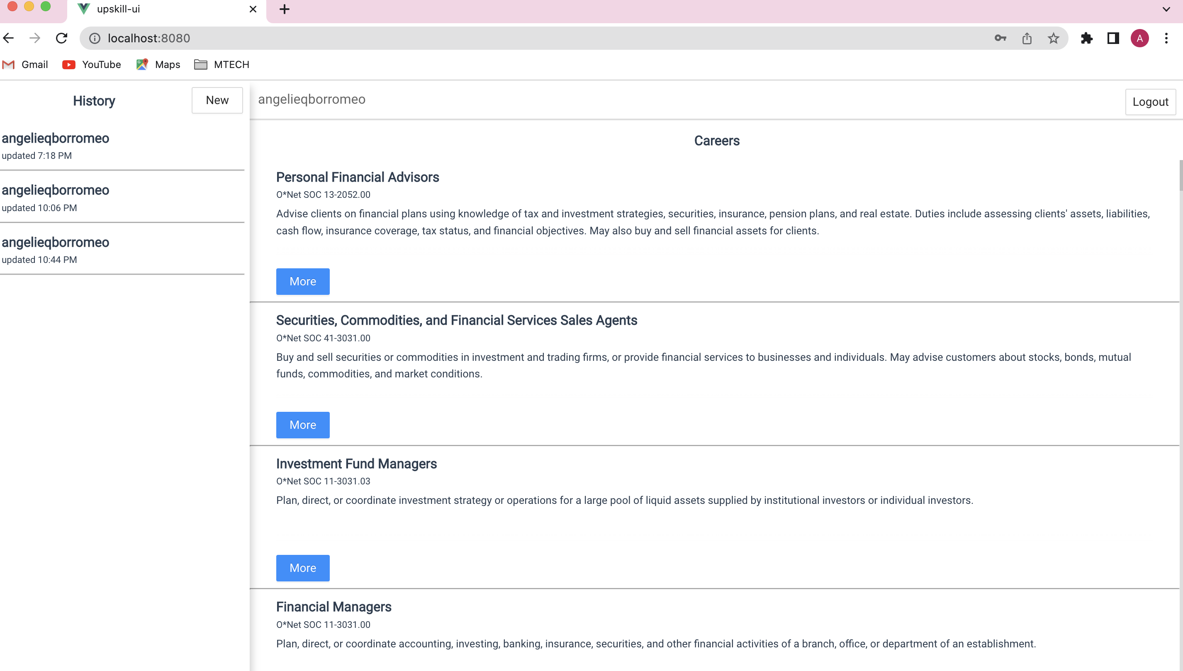

* Furter details about career can be seen such as task details, compensation, career path, available educational programs.

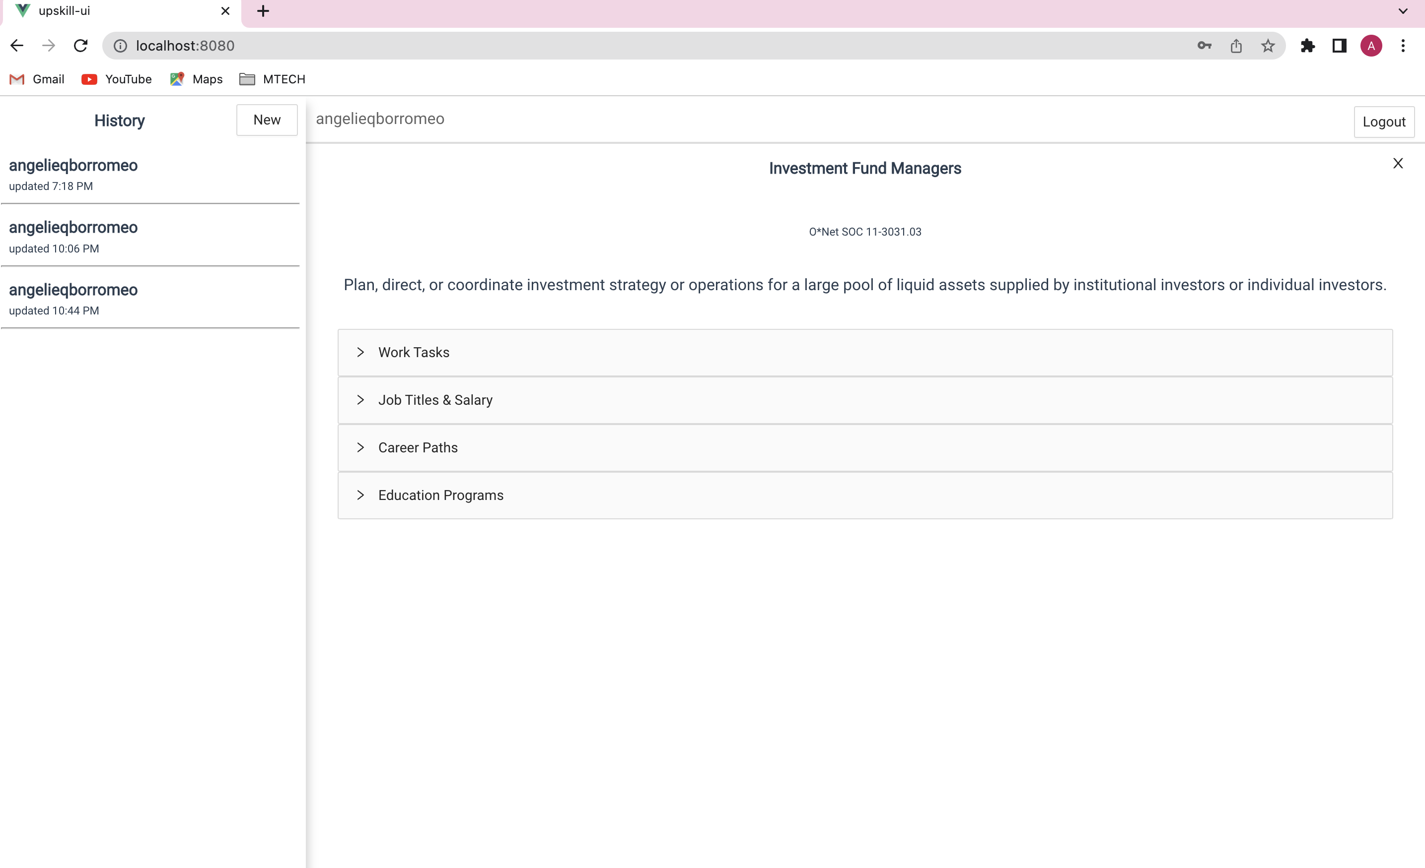

* Example of a details seen on a “Work Tasks”

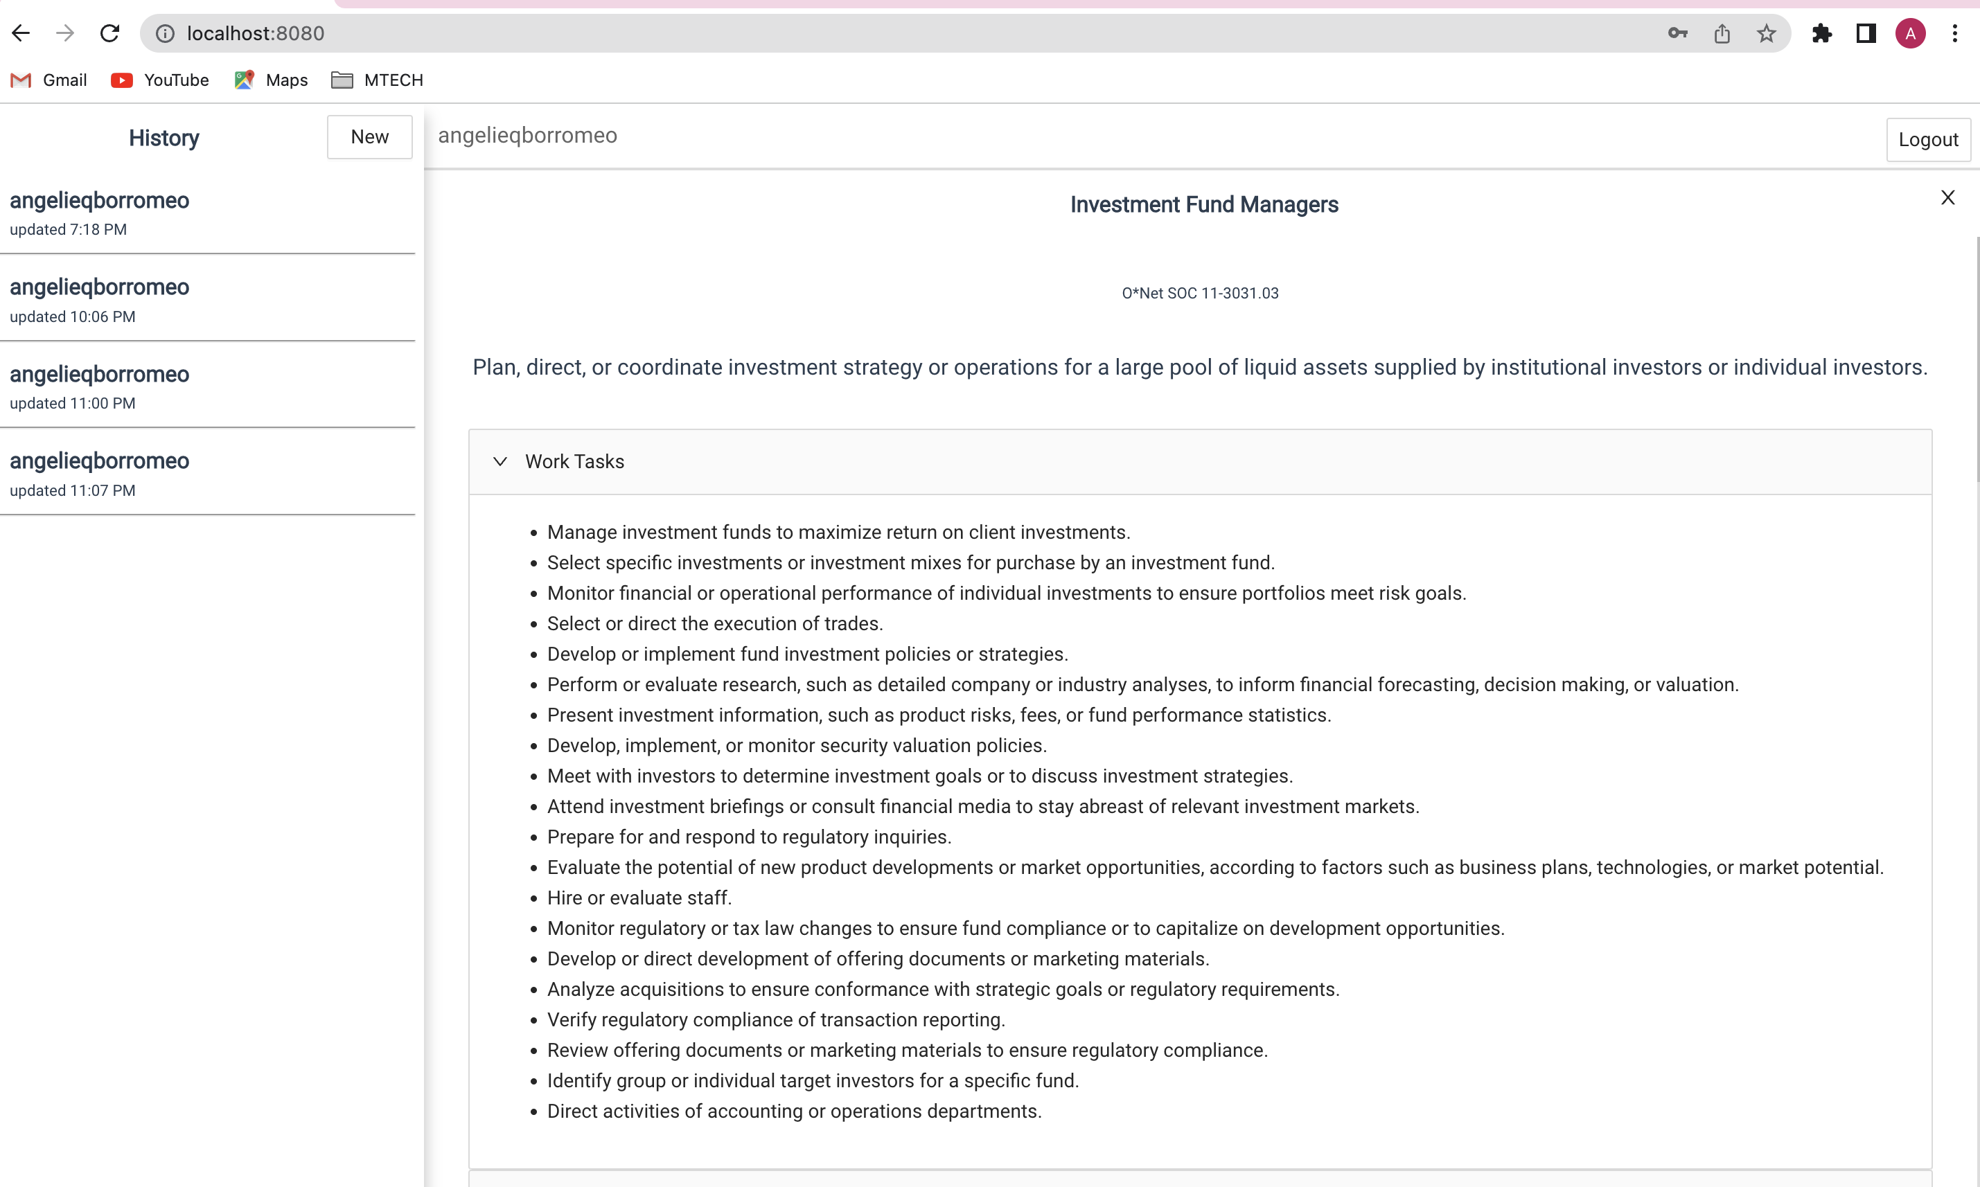

* Example of a details seen on a “Job Tittles & Salary”

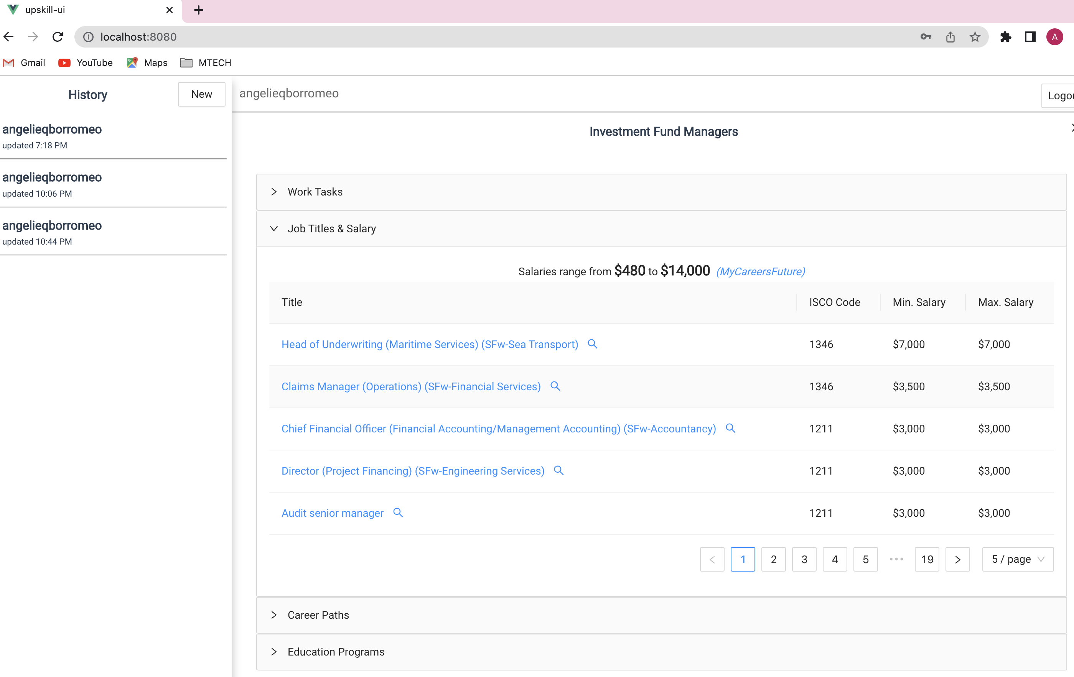

* Example of a details seen on a “Career Paths Graph”

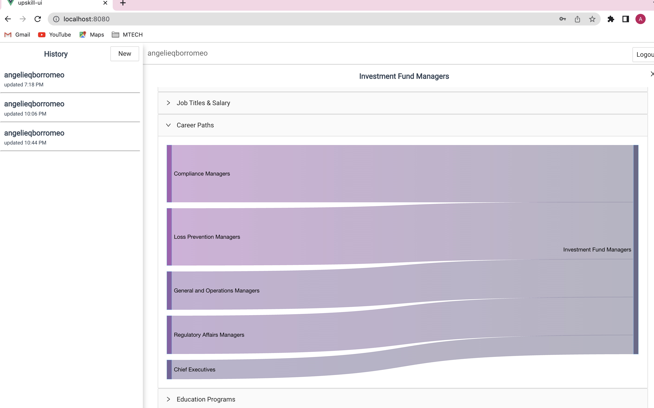

* Example of a details seen on a “Educational Program” available in Singapore.

